Indiana University – Fort Wayne
Faculty Council - Minutes
Zoom Format - Friday, November 5, 2021 at 12:00 p.m.
https://iu.zoom.us/j/84954220191

Welcome, Call to Order 12:05 PM- Vice President, Nila Reimer

Roll Call: IUFW Faculty Council –
Executive Committee Unit Representatives
__President, Aisha Smiley Dental (2): __Nichole Dicke, _x_Brooke Pratt
_x_Vice President, Nila Reimer Health Sciences (1): _x_Tom Foley
__Secretary, Wilhemina Leeuw Medical Imaging (1): x__Missy Fritz
_x_Parliamentarian, Colleen Painter Medical School (1): _x_Jimmy Yen
Nursing (3): _x_Melanie Gall, _x_LeAnn Mayer, __Tara Grier
Public Health (1): __ Ashley Robertson
Social Work (1): __Kris Wise
Guests
IUFW Vice Chancellor of Academic Affairs and Operation, Ann Obergfell
PFW Senate, Presiding Officer, Jeffrey Nowak
Marcia Dixson, PFW

- Adoption of the Agenda –Approved by concensus.
- Approval of the Minutes of the September 3, 2021 Meeting- Approved by concensus.
- M. Dixon, Alliance
  - M. Dixon described purpose and overall mission of Alliance. Faculty share ideas and projects for enhancing student success and quality teaching. An annual showcase is held. Alliance provides an opportunity for faculty collaboration to enhance the learning culture. IUFW faculty are encouraged to participatein Alliance.
- IUFW Vice-Chancellor of AA/O, Ann Obergfell – DEI, Dean Search process.A. Obergfell was unable to attend the meeting. A summary if the report was sent with the IUFW Faculty Council November 5th meeting agenda (See Appendix A: Report from Administration).

Committee Reports -
- Academic Affairs – Chr. Melanie Gall, Kawther Hamesh, Matt Powell- No new updates.
- Faculty Affairs – Chr. LeAnn Mayer, Brooke Pratt, and Kristen Bassett-No new updates.
- Nominations and Elections Report – Jimmy Yen, Kris Wise, Tom Foley
  - Some standing committee members are past the 2-year timeframe. Executive Committee positions will also be available. A call for nominations will be needed.
- Student Affairs – Chr. Tom Foley, Ashley Robertson, and Colleen Painter
  - Student Affaris Committee is planning a spring event for students. A focus on the IUFW Student Goverance Association will take place to recruit students. N. Reimer suggested Student Affairs’ providing presentations about SGA to the IUFW Schools.
- University Resources Policy – Chr. Michelle Fritz, Jennifer Klepper, and Jennifer Bryant-No new updates.
- IUPUI IFC – IUFW Representative, Jan Nes
  - J. Nes reported the IU Faculty Council monthly updates. (See Appendix B: Report from IUPUI Faculty Council Meetings, Fall 2021).
  - IU Faculty Council
- PFW Senate Report – President, Aisha Smiley.-Deferred until February meeting.

- Old Business:

  - N. Reimer announced the taskforce’s status of the IUFW Bylaws revision. The removal of “Ex-Officio” for the parliamentarian role was unanimously approved.
  - Also, in our Constitution, Section E. titled, Affiliates, 1.1-1.4 need clarification. IUFW Faculty Council meeting dates (specifically the April date due to Good Friday) and meeting time limits were mentioned for potential need of change. Further bylaws and constitution proposed changes will be shared at the next IUFW Faculty Council meeting.
  - Student Goverannce Association (SGA) was discussed. T. Foley stated that some students are engaged in the Institute for Healthcare Improvement (IHI). J. Ness pointed out that clarity is needed about our memorandum of understanding (MOU) for our IUFW and also the Purdue SGA.We need to ensure optimal financial support for the students’ SGA. T. Foley suggested considering initiation of a SGA student representative as soon as possible by sending an IUFW school-wide nomination-vote for a student representative. Vice-Chancellor Obergfell or J. Huffman, Student Central, may have information about our current SGA MOU.

- New Business:

  - T, Foley discussed a possibility of future investigation about a focus on health of IUFW for the next three years. Data Collection is needed. Information about faculty/staff using health services, health and wellness, and health-related benefits would be helpful information. M. Fritz suggested involving human resources. A. Reese has presented to IUFW and may provide insightful information to add for inquiry about our focus on healthy IUFW.
  - J. Ness presented a question about the new IUFW DEI position: Is this a full-time position? Perhaps Vice-Chancellor Obergfell could address this question. Faculty discussed the need for clarity in what actions have been taken and our goals at IUFW for ensuring DEI.

- Announcements and Remarks:

Future Meetings: Friday, February 4, 2022
Friday, April 1, 2022
IUFW Faculty Affairs Website: https://www.iufw.edu/faculty-council/

Adjournment: 1:05 p.m.
Recorder: Nila Reimer

Appendix A
Report From the Administration

TO: Faculty Council
From: Ann M. Obergfell
RE: Report from the administration
DATE: November 5, 2021

I am sorry I am not able to attend the meeting today but am in Indianapolis for events surrounding President Whitten’s inauguration.

REPORT:
IU Fort Wayne Vaccination rate (FROM IU COVID dashboard)
88.4% faculty and staff are vaccinated
75.9% Students are vaccinated

COVID-19 TESTING
We continue to test faculty staff and students who received an exemption from the vaccine mandate. Testing approximately 150 per week.

PRESIDENT WHITTEN’S VISIT:
President Whitten will be on campus November 11. She will be meeting with Faculty and staff from 2:30 to 3 PM. Please plan on attending and RSVP at the link in the e-mail sent from my office. We want to make sure we have the right size room for the group.

COMMENCEMENT:
The first IU Fort Wayne graduation celebration will be held on May 13th in the early evening (time TBD) at the Foellinger theater at Franke Park. Planning is under way and we are hoping as many as faculty as possible will attend and support the graduating students. Please mark your calendar for this important event.

DIVERSITY, EQUITY AND INCLUSION:
Diversity, Equity and Inclusion is an important and fundamental initiative for our campus as well as the entire University. We had a fledgling Diversity Council formed but COVID seemed to sidetrack multiple initiatives including the important one. In an attempt to revitalize the DEI Council, I would like the faculty council to work with the staff council to help create a council that will serve the entire campus. Additionally, I have also requested a diversity officer for the campus who can help spearhead our DEI work and help move this initiative forward. While we all have a responsibility for making this a welcoming campus, having an individual assigned to this work will be critical as we move toward a more inclusive campus and community.

Appendix B
Report from IUPUI Faculty Council Meetings, Fall 2021
IUFW Faculty Council
Report from IUPUI Faculty Council Meetings, Fall 2021. Jan Nes, IUFW Representative to IUPUI Faculty Council November 2, 2021
Three IUPUI FC meetings: September 14, October 5, 2021 and November 2, 2021. November 23, 2021 meeting is cancelled.
Updates from IUPUI Faculty Council September 14th meeting
- Agenda approved for 9/14/21 and minutes approved from May 4, 2021 meeting.
- Remarks from Chancellor Paydar
  - Celebrated the work of faculty and staff during the past 19 months under COVID19 conditions. Noted that 88% of the entire campus community has been vaccinated: 92% of faculty and staff and 86.7% of students. Encouraged everyone to continue to review the COVID FAQ page for updates and information at https://www.iu.edu/covid/faq/index.html. Chancellor Paydar reminded all that flu shots are also available on campuses.
  - Enrollment is down by 5.8% inclusive of IUPUI, IUPUC and IUFW campuses. IUFW is down by 6.3%; IUPUC is down by 17.6% and IUPUI is down by 5.2%. The IUB campus is up in part because it draws from regional as well as out of state more so than the regional campuses.
▪ For the IUPUI campus,
    - White student enrollment -8%
    - Asian American enrollment +1.4% & comprise 7% total enrollment
    - Latinx enrollment +3.3% and comprise 10% of total campus enrollment
    - African American -5.7% constituting 9.8% of total enrollment.
    - International enrollment is +2.3% but there was huge drop in
international enrollment last year due to COVID19 so 2.3% is not
particularly significant.
  - Funding. There will be a deficit of $6 million due to enrollment declines. This year, the
University received back the 7% that had been cut the previous year. Campus will
increase its state appropriations by $11 million.
  - $27.7 Million was approved, received, and distributed from the Higher Education
Emergency Relief Fund III (HEERF III) to roughly 12000 students.
  - Chancellor Paydar announced appointments and administrative reviews. He also
announced the completion of Innovation Hall.
  - Commencement will be on May 14, 2022 at Carroll Stadium; should an alternative date
be needed it will be May 15.
  - Paydar will be retiring March 1, 2022. Search is underway for his replacement.
  - Dr. Kathy Johnson, Executive Vice Chancellor and Chief Academic Officer, reported out
on the Integrative DEI Case and parameters for schools and departments to consider.

- John Watson, President, IUPUI Faculty Council reported on IFC achievements the previous year including:
  - endorsing the United Nations Sustainable Development Goals Initiative,
  - agreeing to allow tenure-track faculty at the associate or full level to serve on
committees reviewing the teaching professor candidates, to write chair letters, and
serve as external reviewers for a period of three years.
  - endorsing the Alliance of Distinguished Entitled Professors document titled, “Becoming
a More Equitable and Inclusive Institution”.
  - approving the Integrative DEI promotion and tenure case for tenure-track faculty.
  - approving the ability for faculty to document changes to teaching, research, and
service during the pandemic as a COVID-19 annual review supplemental document.
  - approving two wellness days for the spring 2021 semester; and
  - finally providing an endorsement statement about the COVID-19 vaccination
requirement.
- Election Slate was shared with all.
- IUPUI Fresh Start Through Academic Renewal Policy shared by Brenda Blalock, Chair, Academic
Affairs Committee.
Updates from IUPUI Faculty Council October 5, 2021 meeting
- Agenda approved for 10/5/21 and minutes approved from September 14, 2021 meeting.
- Remarks from Nassar Paydar
  - Provided an overview of the $30 million available for hiring TT faculty from underrepresented groups.
  - Noted that IUPUI is looking into creating a pathway to hire students of color upon graduation.
  - Addressed campus safety issues on the Indianapolis campus.
  - Reported on flu shot availability at the IUPUI Campus Center.
  - Noted the inauguration of Pamela Whitten is Nov. 4 and 5. November 4 at IUB and Nov.
5 at IUPUI.
  - Reported that roughly 3000 participated in the IUPUI Regatta on 9/26/21.
- John Watson, Pres. Of IUPUI Faculty Council reported on committee work this academic year, beginning this fall: Budgetary Affairs, Faculty Affairs, Policy Review Committee and Technology Committee.
- Election Slate Presented.
- Discussion and Vote taken on IUPUI Fresh Start Through Academic Renewal Policy. Brenda
Blalock, Chair of Academic Affairs Committee provided the overview of the policy which replaces the IUPUI Forgiveness Policy. Revisions to this former policy are fairly extensive, details of which can be found here: https://facultycouncil.iupui.edu/FCContent/Html/Media/FCContent/committees/academic_affa irs/forgiveness-policy%20revisions_v2-withtrackchanges2021.pdf.
- Standing Committee Reports – One report provided by Amy Blevins, Chair, Faculty Guide Committee on policy revisions and the addition of some new policies. Updated all links within the guide. If you wish to review the updated guide, it can be found here:
https://facultycouncil.iupui.edu/FCContent/Html/Media/FCContent/committees/handbook/fac
ulty_guide.pdf.
- Aaron Carroll, Chief Medical Officer for IU provided updates on COVID19 and entertained and
answered numerous questions.
- Staff Council provided their report which included updates on Paw’s Pantry, their top three
goals for the year (see minutes for details on these goals) and reported that committees are off to a good start.
Updates from Nov. 2, 2021 IUPUI Faculty Council
- Agenda approved for 11/2/21 and minutes approved from October 5, 2021 meeting.
- Remarks from Nassar Paydar
  - Nassar Paydar presented more information on enrollment
  - Nassar Paydar also reported on Research and Sponsored Awards. See screen shot below. Assumption is that all declines are a direct result of the pandemic.
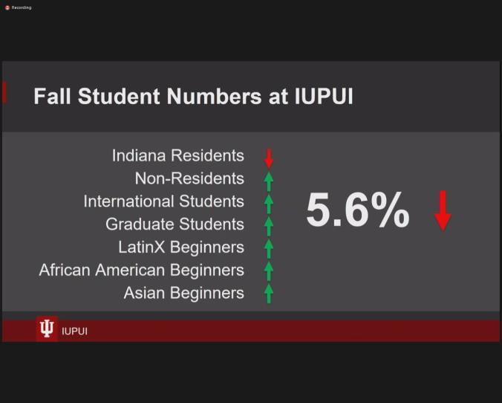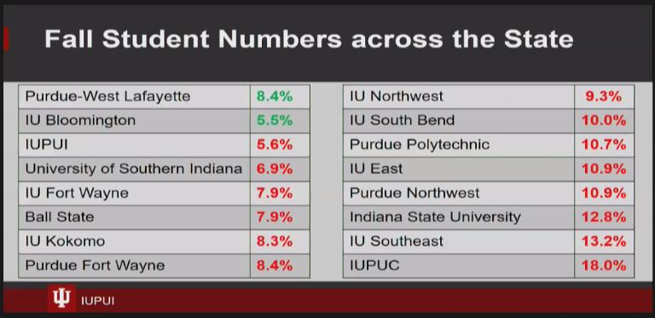

- 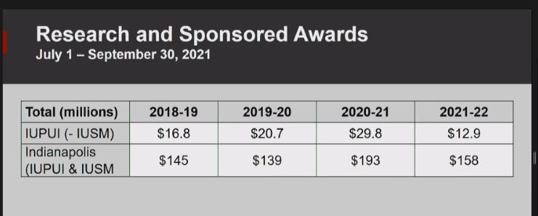
- UFC met last week and based on Pres. Whitten’s recommendation, endorsed Juneteenth (6/19) as a new official University Holiday. This will go into effect 2022. Academic calendar for summer classes will need some adjustments.
- Have started 3 committees for administrative reviews. Chairs have been selected to administer these committees for reviews of select administrators (see full minutes for details).
- Inauguration events will occur on Friday, 1:30, November 5, 2021, Campus Center Theatre, Indianapolis Campus for President Whitten. Encouraged all to participate.
- Flu shots – Nov. 9th, 9:00-3:00pm (high dose version for folks over 65). Booster shots Nov. 18 and Nov. 30 for COVID19. All educators are recommended to get the booster for Pfizer/Covid 19. Check “health.iu.edu” for more details.
- IUPUI will be at Glasgow – two faculty leaders will be in attendance for the Glasgow Climate Change Conference October 31-Nov. 12, 2021.
- Updates from John Watson:
  - Voted in proposed revisions to discrimination, sexual harassment policies.
  - Thanks everyone for taking the IFC survey and noted that results were welcomed,
particularly about faculty governance. Survey results indicated that there was some confusion about what shared governance actually is, so IFC will need to do some additional clarifying for faculty.
- Results from Election
• Presented results as well as the slate for some additional voting. Voting will be launched via qualtrics by the end of the week, November 5, 2021.
5. Integrated DEI cases: Rachel Applegate.
- Rachel Applegate presented an overview of the Integrative DEI case for Lecturers/Teaching Professor and Clinical faculty cases. (See agenda and subsequent minutes for full details).
- Major points from planning work:
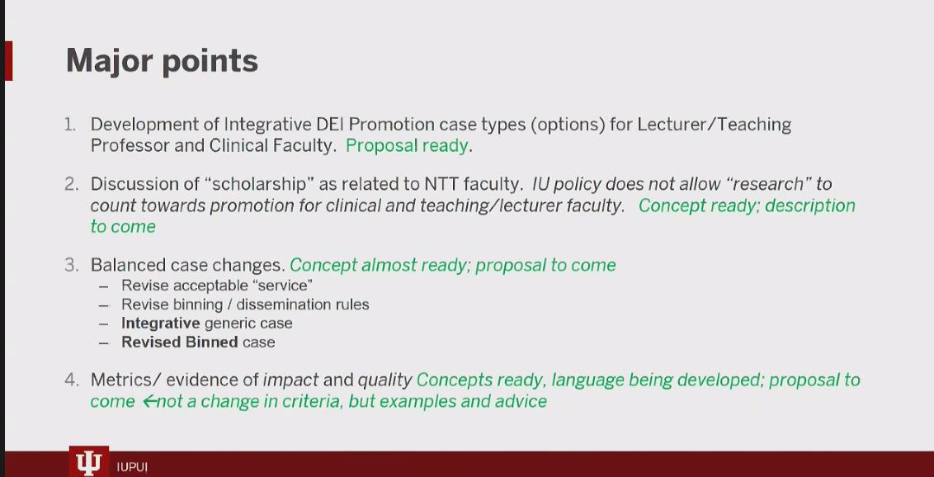
Planning is ongoing. Metrics are being discussed with a focus on two things: 1) quality and 2) impact (i.e., what difference does the work make). They have come up with a non-exhaustive list of examples of measures. Examples will be published in an appendix to the criteria.
Rachel also noted that the school needs to provide guidance to reviewers on the impact of COVID19 on P&T. See below screenshots.
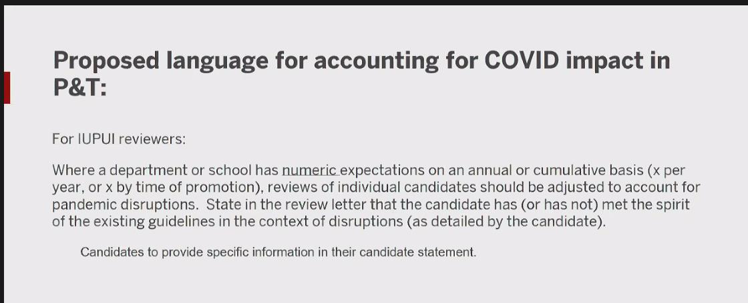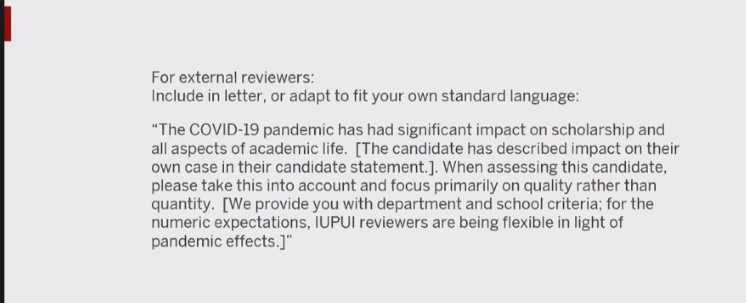
6. Teaching Professor Language:
Motion made to endorse an update to Teaching Professor Language by Phil Goff, Member, IFC. Asking for an endorsement of the idea of to rename lecturer positions to Assistant Teaching Professor and Associate Teaching Professor to shift away from the lecturer language, specifically Lecturer and Senior Lecturer). Vote taken, motion endorsed.
7. Athletic Affairs Committee.
First Read. Policy proposal related to missed class time by Jennifer Guiliano, Chair of the committee. Proposed changes will put language into the existing policy that further explicates alternatives to attendance so that athlete students have relevant and legitimate options for missed classes. The list can be helpful to faculty as well. The ownness is on the student to provide an alternative to a missed class. It does not require a faculty member to come up with an alternative. See the circular in the IUPUI FC Agenda for additional details. Committee will return at next meeting for second read and a vote.
8. Juneteenth Observance.
Academic Affairs Committee (Brenda Blacklock, Chair; Kim Lewis, Registrar) [Discussion and Vote] Juneteenth: Observance and the Academic Calendar. Kim Lewis explained how the institution of Juneteenth Day will impact the academic calendar. See the screenshots below:
See calendar visual below:
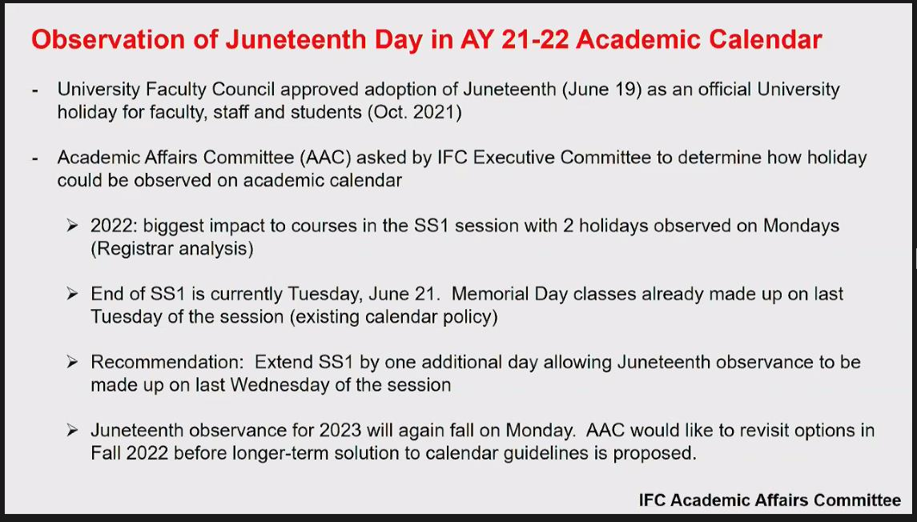
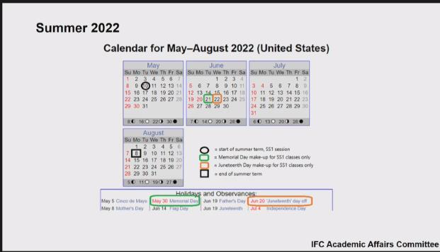

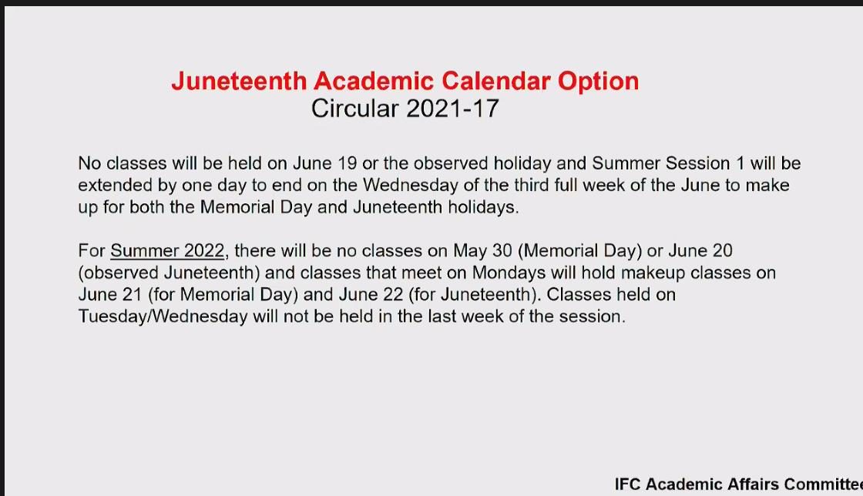

Policy will only impact Summer 2022. Committee will study further for longer term calendar implications. Vote taken. Endorsement of this policy change passed for Summer 2022.
9. Staff Council submitted updates/reports. See minutes once they are available.

